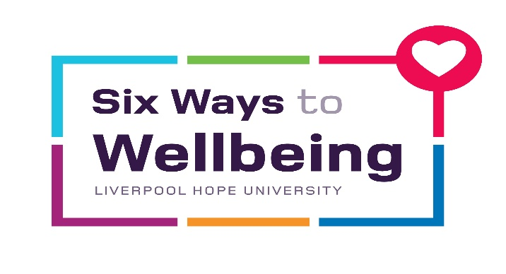
Desk Yoga
Yoga in the office can be fun, innovative and relaxing with many long term benefits. Prolonged work on the computer strains the neck, shoulder and back muscles, which leads to tension and stiffness. Unless attended to properly, it could impact your ability to function effectively at the workplace, affecting your overall quality of life.
Desk yoga comprises of a sequence of simple exercises you can perform quite unobtrusively at your desk, at any time of the day. Making desk yoga exercises a part of your daily routine can work wonders as they wipe away body pain, fatigue and tension and increase overall muscle strength and flexibility, keeping you fresh and revitalised through the day. The exercises don’t demand much time, and can be done in spurts throughout the day, sparing you from unnecessary long term discomfort
Desk Yoga is therefore a great option for people whose daily working lives involve a lot of sitting down, and who experience any of the following; lower back issues, tight shoulders, frequent headaches, poor posture and breathing, high levels of work-related stress or energy levels that drop mid-afternoon.
Key benefits include:
Prevention of lower back issues. The Desk Yoga postures stretch out muscles around the lumbar vertebrae to counteract the compression of sitting on our bottoms! Tight hip flexors and the piriformis are stretched out, preventing sciatica.
Opening of tight shoulders. Most of the day we spend with our arms in front of us and this tightens the shoulders. Desk Yoga helps to mobilise the joints and expand the front of the chest.
Loosening stiff necks. We very rarely turn our heads and most of us carry stress and tension in our necks. Desk Yoga helps to relieve this tension.
Improving energy levels. Desk Yoga involves postures that open the chest and heart area, therefore increasing oxygen uptake and increased vitality.
Increased sense of wellbeing. Taking time out to do yoga postures can help people to bring their attention to themselves in the present moment and inspire a sense of connectedness. This can help people to cope with elevated levels of stress and tension.
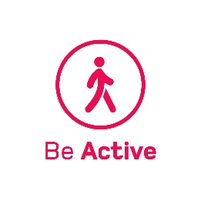
Neck Roll
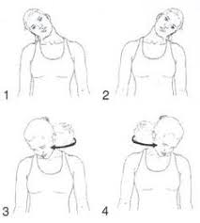

Close your eyes and let your chin drop down to your chest.
Begin the circular motion of your neck slowly, by moving the right ear to the right shoulder, taking the head backwards and then bringing the left ear to the left shoulder.
Keep your shoulders loose and relax away from the ears.
Rotate your neck 3-5 times and then switch directions.

Cat and Cow Stretch
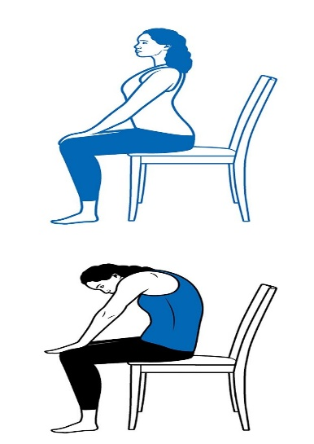

Keep your feet on the floor and bring both hands on your knees.
While inhaling, stretch your back backwards and look towards the ceiling.
While exhaling, stretch your back forward and drop your head forward, squeezing your navel to the spine.
Repeat this exercise for 5-10 breaths

Seated Forward Bend
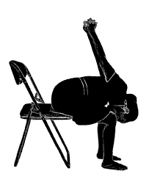

Remaining seated, keep your feet on the floor
Take your arms behind the lower back, keep your back straight and interlace your fingers behind your back
Bending forward from the waist, bring your interlaced hands over your back
Rest your chest on your thighs and relax your neck
Hold for 5-10 breaths.

Eagle Arms

Stretch your arms straight in front of your body and parallel to the floor. Palms facing the ceiling.
Cross your right arm over the left (bend your arm slightly at the elbow if needed). Bring both palms together. Lift both elbows. The shoulders slide down your back.
Hold for 5-10 breaths
Repeat this exercise with the left arm over the right

Seated Spinal Twist
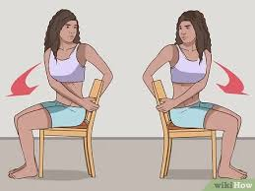

Sit sideways in your chair.
Place your feet flat on the floor.
Holding the back of the chair with both hands, twist your waist to the right towards the back of the chair.
Hold for 5-10 breaths. Repeat this exercise on the other side.

Reverse Prayer
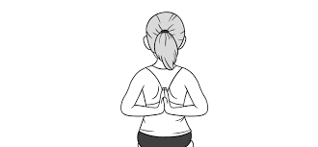
Move your hands into a prayer position behind your back with your fingers pointing down.
Carefully turn your fingers towards your back and then towards the ceiling
Hold for 5-10 breaths.
(If your palms don’t meet, hold on to your elbows)

Cow face
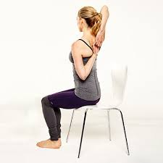

Lifting your right hand, drop it behind your head and see if your left hand can reach it from behind your back
If not, hold a strap, belt, tie or towel with your right hand and get your left hand to reach back and grab hold of it
As you relax into this stretch work to move your hands closer together.
Hold for as long as 5-10 breaths
Repeat on the other side

Seated Pigeon
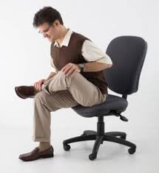

Sitting forward in your chair and lengthen through the spine
Bring your right ankle to rest above you left knee, flexing the right knee out to the side
Slowly take the body forward to the point when you feel resistance and hold for 5-10 breaths
Slowly release and repeat on the other side

Downward facing dog
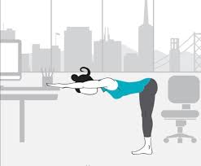

Use a sturdy chair or your desk
Stand 2’ away from the front of the chair or desk
Rest your hands on the front edge
Inhale and step the feet back an additional 1-2’, resting the feet comfortably on the floor
Exhale and shift your hips back and lengthen through the spine to an inverted “V”
Hold for 5-10 breaths

